RESEARCH PROJECT
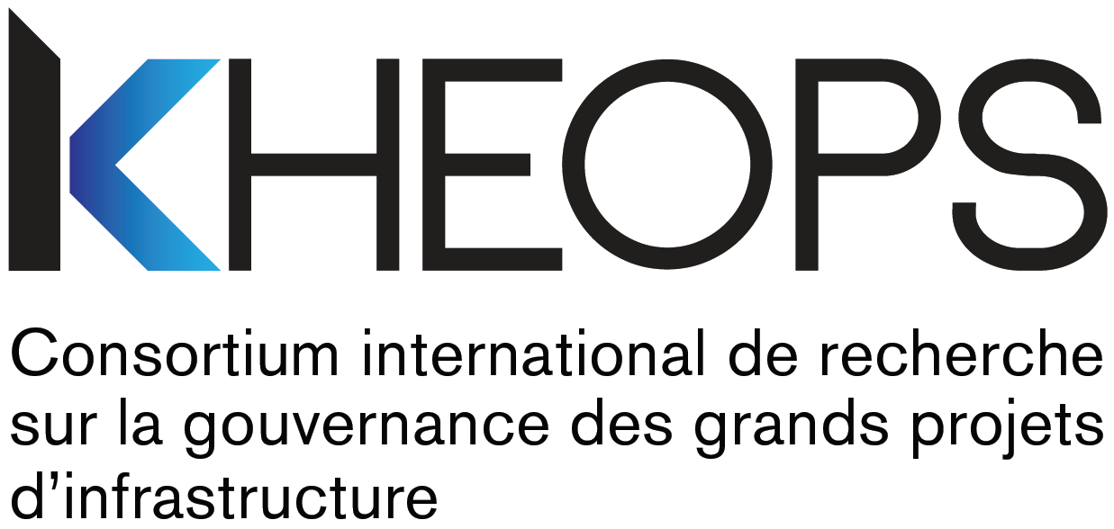

SOCIAL VALUE OF THE SOLAR PARK
Confirmation of Interest Form – Support for Start-Up of a Research Project

Identification

Researcher responsible for application – Principal investigator

Last name, First name
Title
Home institution
Faculty
Department
Email

Co-investigator(s) – Add as many entries as necessary

Last name, First name
Title
Home institution
Faculty
Department
Email

Last name, First name
Title
Home institution
Faculty
Department
Email

Main disciplines related to this project – Add as many entries as necessary

1.
2.
3.

Project

Title of project

Summary of project – Approximately 10 lines

Documentation

Make sure that you attach all of the following documents to this duly completed form, in PDF format – Check.
☐ | - Description of project – 3 pages  Include the following aspects:  - Research question and objectives;  - Approach and proposed method;  - Anticipated benefits;  - Overview of principal investigator’s and co-investigators’ expertise and contributions;  - Target program/granting agency/date for an application for funding and project’s fit with the objectives of the target program.
☐ | - Bibliographic references – maximum 1/2 page
☐ | - Detailed budget and justification of expenditures – maximum 2 pages  Copy, paste and complete the following table, justifying each budget item:  - Student personnel: salary and benefits  - Other personnel: salary and benefits (must be justified)  - Equipment and supplies  - Travel and accommodations  - Other  Total  Specify:  - What activities will be carried out with the financial support;  - The importance of these activities with a view to submitting the grant application;  - The status of the person who will carry out these activities;  - The work schedule;  - If applicable, explain how funding from other funding sources already at your disposal will complement this grant.
☐ | - CVs of principal investigator and all co-investigators  Provide the CVs in the format stipulated by the granting agency targeted for a funding application.

Send your duly completed package (form and attachments in PDF format) to
concours@kheops.ca
By 5 december 2021, 5 p.m.

Undertakings and signature

By submitting their application packages, project researchers undertake to:
- Respect, and have their team members respect, the rules and principles set out in the policies of the Fonds de recherche du Québec:
- Common general rules
- Responsible conduct of research
- Research ethics policy
- Action plan on intellectual property management
- Principle of equity, diversity and inclusion
- Action plan for environmental responsibility in research

- Provide the post-financing deliverables (part 1 and part 2) as described in the call for interest, as follows:
- Issue a short administrative report;
- Follow up regarding the results of the grant competition;
- Write a research report;
- Participate in a knowledge mobilization activity;
- Provide the list of publications resulting from the project.

- Mention the financial support from KHEOPS – International Research Consortium on the Governance of Large Infrastructure Projects in any report, article, publication or communication resulting from the financial assistance granted;

- Authorize KHEOPS to publish, reproduce, modify for popularization purposes, distribute, translate and communicate, free of charge, without time or territorial limitations, and in any format and by any means whatever, the post-financing deliverables and research results, including for purposes of carrying out subsequent research work.

In accordance with KHEOPS’ mission and its commitments to its partners, and in accordance with universities’ teaching and research missions, the researchers who apply must adhere to the principle of promoting the sharing and dissemination of the research results generated by the project, or resulting therefrom, in particular by sharing them with KHEOPS, which will also enable its partners to benefit from them.

- Be sure to inform their collaborators of the conditions governing the provision of funding by KHEOPS and obtain their undertakings accordingly.

Explanation of the Conditions Regarding Intellectual Property
Recognition of intellectual property rights
In accordance with the practices in force in the research community, KHEOPS recognizes researchers’ intellectual property rights to their work (e.g., research reports, analysis documents, etc.) and the results of research emerging from work funded by this financing program. Moreover, although authors retain the intellectual property rights to their work and research results, the financing granted by KHEOPS is conditional upon the recognition of certain rights of use by KHEOPS and its partners of the said work and results, as set out herein.
Disclosure of research results
The researcher responsible for the application undertakes to fully disclose the results of the research, as soon as possible, through follow-up activities, the research report, the knowledge mobilization activity, publications, or otherwise.
Appropriate citation
KHEOPS undertakes to respect the usual citation rules in effect in the university community in all circumstances, including in the case of subsequent work based on the research results. When using the research report, KHEOPS undertakes to mention the authors, the date of completion and the copyright notice ©KHEOPS.
Acceptance of grant and user licence for KHEOPS
By accepting the grant, the principal investigator grants KHEOPS the non-exclusive right, transferable and irrevocable, to publish, reproduce, distribute, translate, modify for popularization purposes, and communicate, in any format and by any means whatever, the post-financing deliverables and research results for which the grant constitutes consideration, including for purposes of carrying out subsequent research work. This licence is granted free of charge, without time or territorial limitations. The principal investigator waives any claim to royalties or application of his/her moral rights upon such use by KHEOPS and its partners.
The principal investigator warrants to KHEOPS that he/she holds the rights enabling him/her to grant the licence described above under the conditions stipulated herein and that he/she will obtain from his/her collaborators a licence enabling him/her to honour his/her undertakings to KHEOPS in this regard.
The parties hereto agree to negotiate in good faith the settlement of any dispute relating to intellectual property upon receipt of a notice in writing informing them of the existence of a dispute, and waive the right to recourse to the courts in the case of a dispute, except to obtain an injunction or any order that is the exclusive jurisdiction of the courts. If occasion arises, this dispute and any related proceedings must be heard in Montreal.

Signature

Signature of principal investigator |  | Date
Last name, First name |  | Title

For more information
Please contact Alexandra Prohet
prohet.alexandra@kheops.ca

