KHEOPS KNOWLEDGE SYNTHESIS
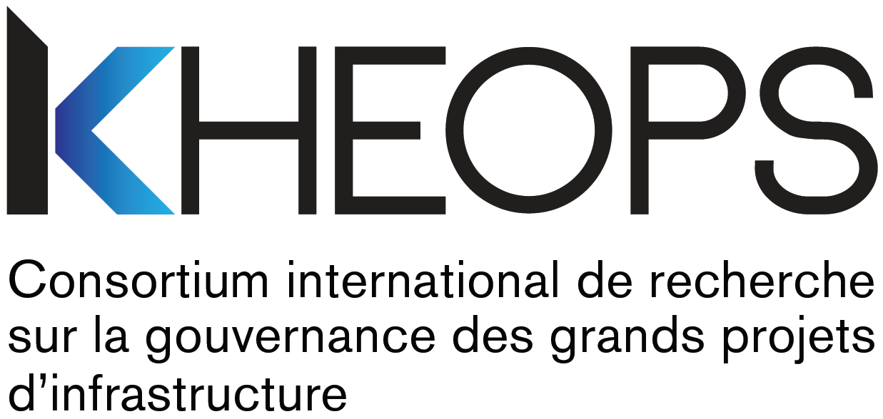

PARTNERSHIP PROGRAM
Application Form

Identification

Researcher responsible for application – Principal investigator

Last name, First name
Title
Home institution
Faculty
Department
Email

Co-investigator(s) – Add as many entries as necessary

Last name, First name
Title
Home institution
Faculty
Department
Email

Last name, First name
Title
Home institution
Faculty
Department
Email

Non-academic partner(s) – Add as many entries as necessary

Last name, First name
Title
Home institution
Faculty
Department
Email

Project

Title of project

Summary of project – maximum 250 words

KHEOPS research areas and areas of interest * – Check
Research areas | ☐ Area 1 – Rethinking the valuation of major infrastructure projects  ☐ Area 2 – Designing sustainable governance
Areas of interest | ☐ Built environment  ☐ Transportation  ☐ Energy and natural resources
* For more information

Describe how the project is aligned with the KHEOPS research areas for scientific programming and target areas of interest – maximum 250 words

Documentation

Make sure that you attach all of the following documents to this duly completed form, in PDF format – Check.
☐ | - Description of project – 5 pages  Include the following aspects:  - Context, research question and objectives;  - Approach, proposed method and work schedule;  - Response to the research needs identified by partners in the practice environment(s), originality of project, importance of expected contributions and other anticipated benefits;  - Overview of principal investigator’s and co-investigators’ expertise and contributions, disciplines or classes of disciplines involved, non-academic partner’s involvement and contribution, relevance of team and synergy of expertise;  - Description of students’ roles and responsibilities, project’s contribution to training highly qualified personnel.
☐ | - Bibliographic references – maximum 2 pages
☐ | - Knowledge mobilization and transfer plan – maximum 1 page  Include the following aspects:  - Description of target audiences and description of objectives for each one;  - Description of planned mobilization and transfer activities;  - Schedule of activities.  Useful link
☐ | - Detailed budget and justification of expenditures – maximum 2 pages  Eligible expenditures are:  - Salaries, wages and benefits (student, postdoctoral fellow, research professional, research technician);  - Fees;  - Student scholarships;  - Research materials and supplies (maximum $2,000);  - Equipment leasing or purchase;  - Travel and accommodation costs related to project execution, dissemination and transfer;  - Knowledge dissemination and transfer costs (production, publishing, copying, translation, editing).
☐ | - CVs of principal investigator and all co-investigators  Provide the CVs in the Canadian Common CV format.  Useful link
☐ | - Commitment or support letter from non-academic partner(s)

Send your complete package (form and documentation in PDF format) to
concours@kheops.ca
By November 21, 2021, 5 p.m.

Undertakings and signature

By submitting their application packages, project researchers undertake to:
- Respect, and have their team members respect, the rules and principles set out in the policies of the Fonds de recherche du Québec:
- Common general rules
- Responsible conduct of research
- Research ethics policy
- Action plan on intellectual property management
- Principle of equity, diversity and inclusion
- Action plan for environmental responsibility in research

- Provide the post-financing deliverables as described in the KHEOPS Knowledge Synthesis Partnership Program call, as follows:
- Write a progress report;
- Write a research report;
- Issue a short administrative report;
- Participate in a knowledge mobilization activity.

- Mention the financial support from KHEOPS – International Research Consortium on the Governance of Large Infrastructure Projects in any report, article, publication or communication resulting from the financial assistance granted;

- Authorize KHEOPS to publish, reproduce, modify for popularization purposes, distribute, translate and communicate, free of charge, without time or territorial limitations, and in any format and by any means whatever, the post-financing deliverables and research results, including for purposes of carrying out subsequent research work.

In accordance with KHEOPS’ mission and its commitments to its partners, and in accordance with universities’ teaching and research missions, the researchers who apply must adhere to the principle of promoting the sharing and dissemination of the research results generated by the project, or resulting therefrom, in particular by sharing them with KHEOPS, which will also enable its partners to benefit from them.

- Be sure to inform their collaborators of the conditions governing the provision of funding by KHEOPS and obtain their undertakings accordingly.

Explanation of the Conditions Regarding Intellectual Property
Recognition of intellectual property rights
In accordance with the practices in force in the research community, KHEOPS recognizes researchers’ intellectual property rights to their work (e.g., research reports, analysis documents, etc.) and the results of research emerging from work funded by this financing program. Moreover, although authors retain the intellectual property rights to their work and research results, the financing granted by KHEOPS is conditional upon the recognition of certain rights of use by KHEOPS and its partners of the said work and results, as set out herein.
Disclosure of research results
The researcher responsible for the application undertakes to fully disclose the results of the research, as soon as possible, through follow-up activities, the research report, the knowledge mobilization activity, publications, or otherwise.
Appropriate citation
KHEOPS undertakes to respect the usual citation rules in effect in the university community in all circumstances, including in the case of subsequent work based on the research results. When using the research report, KHEOPS undertakes to mention the authors, the date of completion and the copyright notice ©KHEOPS.
Acceptance of grant and user licence for KHEOPS
By accepting the grant, the principal investigator grants KHEOPS the non-exclusive right, transferable and irrevocable, to publish, reproduce, distribute, translate, modify for popularization purposes, and communicate, in any format and by any means whatever, the post-financing deliverables and research results for which the grant constitutes consideration, including for purposes of carrying out subsequent research work. This licence is granted free of charge, without time or territorial limitations. The principal investigator waives any claim to royalties or application of his/her moral rights upon such use by KHEOPS and its partners.
The principal investigator warrants to KHEOPS that he/she holds the rights enabling him/her to grant the licence described above under the conditions stipulated herein and that he/she will obtain from his/her collaborators a licence enabling him/her to honour his/her undertakings to KHEOPS in this regard.

The parties hereto agree to negotiate in good faith the settlement of any dispute relating to intellectual property upon receipt of a notice in writing informing them of the existence of a dispute, and waive the right to recourse to the courts in the case of a dispute, except to obtain an injunction or any order that is the exclusive jurisdiction of the courts. If occasion arises, this dispute and any related proceedings must be heard in Montreal.

Signature

Signature of principal investigator |  | Date
Last name, First name |  | Title

For more information about this program
Please contact Alexandra Prohet
prohet.alexandra@kheops.ca

